Photography as Social Commentary…
One instrumental aspect of communicating through a camera lens is being able to use photography as not only art, but also as social commentary. A good photographer first observes and investigates and then shoots, albeit quickly because the “perfect” shot is often fleeting.
Combine this with camera skills and lighting techniques and we have a lot to think about.
Photography in regard to social commentary focuses on the integration of documentary photography, research, new technologies, and concepts of social change.
People and events provide great insight into human behavior that, in turn, provides us with the opportunity to observe the impact of, for example, policies and social change on citizens.

The difficult thing about learning how to make art with social commentary is that the subject is so broad. Most representational art, and even some abstract art, contains social commentary in some form. Whether you are using your art to protest a war, glorify a certain image of beauty or lampoon a certain common attitude you object to, you are making some form of social commentary. The difference is when your intention is to inspire social change you have to make sure that the commentary is at the forefront of the art. Make it obvious enough for people to get it without insulting your viewer's intelligence.
Decide on what you want to say. Some popular topics in political art today are environmental destruction and warmongering, but art can also speak about gender roles, public space and education.

Bullying Texting Poverty Eating Disorders Profiling Body Image
Pollution Fast Food Nutrition Technology World False Advertising Censorship
“Online Purchase” by Kerry Furrh 2010

Check out these sites and post a 3-2-1 Reflection
3 things you learned
2 things are inspired by
1 idea you will research, pursue, and shoot for (describe why you chose this).

Early Social Commentary in Photography
http://www.luminous-lint.com/app/theme/362/
David LaChapelle
http://www.culturekiosque.com/nouveau/books/rhebooks3.html
The Women Project
http://www.womenareheroes.be/?en
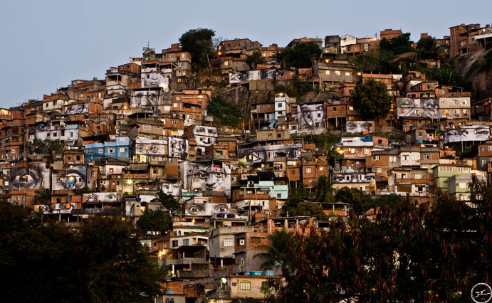
JR is a photographer who takes pictures of “women affected by poverty and violence, and then pastes blown-up prints all over their cities.” He “sticks his pictures to the sides of buses, trains, buildings, and pavement, transforming the towns in which these women live into testaments to their strength and forbearance.”

United Steaks of America
Dominic Episcopo

http://www.fastcompany.com/blog/danielle-sacks/ad-verse-effect/ihungry-ad-agencies-co-opt-their-own-images
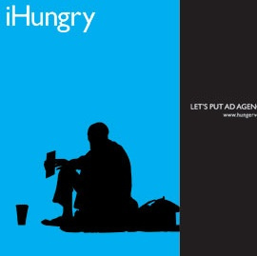
http://noticeverything.wordpress.com/2011/02/14/social-commentary-food-for-thought/
